Style File for IMS Mini-International Workshop on
Advanced Spectroscopy of Correlated Materials (ASCM 13)
H. Miyazaki¹, M. Matsunami² and S. Kimura²
¹Center for Fostering Young and Innovative Researchers, Nagoya Institute of Technology, Nagoya 466-8555, Japan.
² UVSOR Facility, Institute for Molecular Science, and School of Physical Sciences, The Graduate University for Advanced Studies (SOKENDAI), Okazaki 444-8585, Japan

This is the style file for ASCM 13 workshop. Fonts of Times, Times New Roman and Symbol are applicable to your reports, including figure legends and blank spaces. The font sizes and styles for your reports are listed in Table 1.

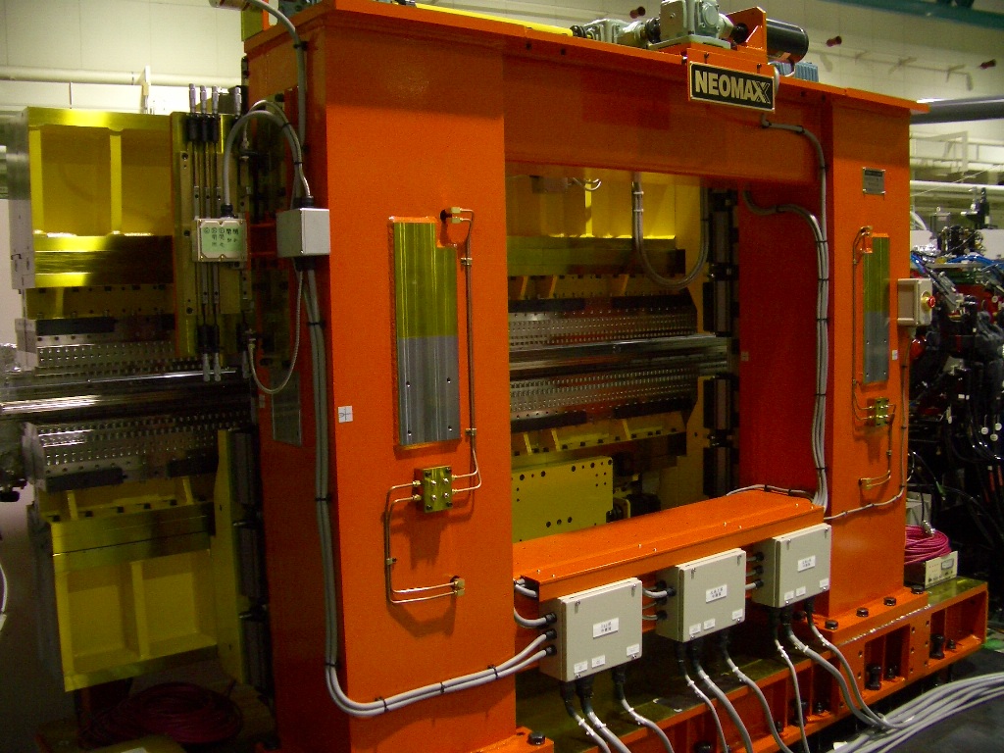

Fig. 1. Photo of the variably polarized U7 undulator.

Table 1. Font size and style.
 | Font Size | Style
Beamline | 10 pt | Normal
Title | 14 pt | Bold
Author Name | 12 pt | Normal
Affiliation | 12 pt | Italic
Text | 10 pt | Normal
Caption | 10 pt | Normal

[1] M. Hosaka, H. Hagiwara and Y. Hikosaka, UVSOR Activity Report 2005 (2006) 1.
[2] T. Kaneyasu et al., Phys. Rev. Letters 101 (2008) 183003.

