Style File for UVSOR Workshop on LEPES 09
Facility + Beamline
T. Ito¹, H. Hagiwara¹ and O. Author²
¹Editorial Board, UVSOR Facility, Institute for Molecular Science, Okazaki 444-8585, Japan
²Institutes, Address ###-####, Country

This is the style file for the format of Users’ Reports. Fonts of Times, Times New Roman and Symbol are applicable to your reports, including figure legends and blank spaces. The font sizes and styles for your reports are listed in Table 1.

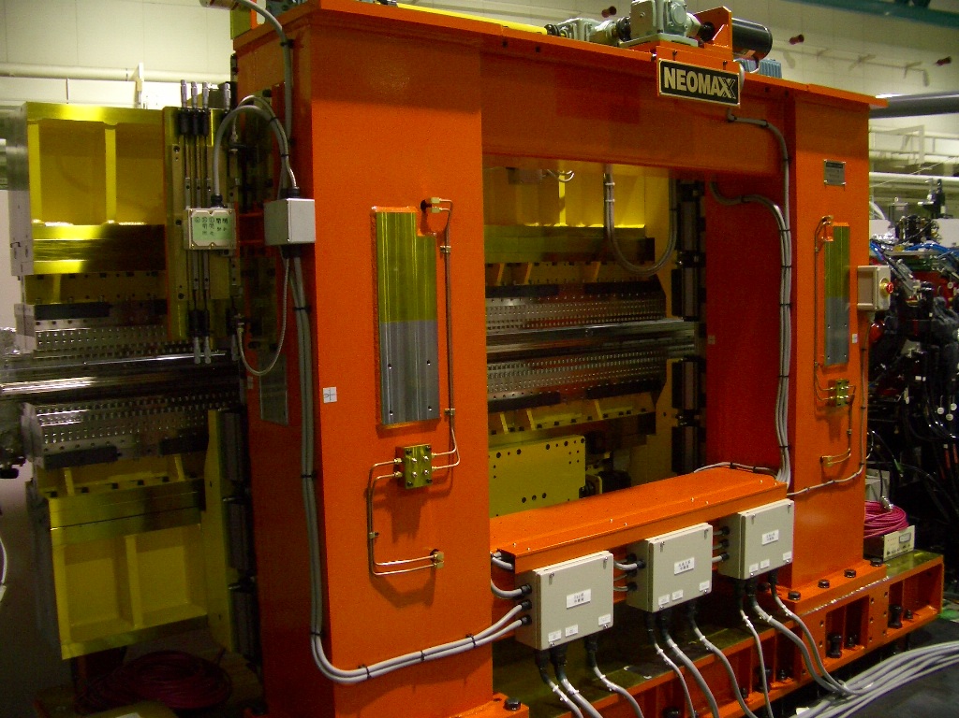

Fig. 1. Photo of the variably polarized U7 undulator.

Table 1. Font size and style.
 | Font Size | Style
Beamline | 10 pt | Normal
Title | 14 pt | Bold
Author Name | 12 pt | Normal
Affiliation | 12 pt | Italic
Text | 10 pt | Normal
Caption | 10 pt | Normal

[1] M. Hosaka, H. Hagiwara and Y. Hikosaka, UVSOR Activity Report 2005 (2006) 1.
[2] T. Kaneyasu et al., Phys. Rev. Letters 101 (2008) 183003.

